

**MY NEWSLETTER SIGN IN**

**UDEMY COURSE PROJECT REPORT**

(Submitted in Partial Fulfilment of the Requirements for the award of the degree)

**Of**

**Bachelor of Technology**

**In**

**Computer Science Engineering**

**Submitted By**

**RITIK AGARWAL**

**02996202718**



**DEPARTMENT OF COMPUTER SCIENCE & ENGINEERING**

**Dr. AKHILESH DAS GUPTA INSTITUTE OF TECHNOLOGY & MANAGEMENT (AFFILIATED TO GURU GOBIND SINGH INDRAPRASTHA UNIVERSITY, DELHI) NEW DELHI – 110053 MAY 2020**

**GURU GOBIND SINGH INDRAPRASTHA UNIVERSITY**

**NEW DELHI**

**2020**

**Table of Contents (Proposed)**

* Certificate
* Overview
* Introduction about course
* Introduction
* Project objective
* Functionality
* System specification
* Tool and platform
* Learning outcome
* Limitation
* Future Scope of project
* Code (Screen Shot)
* Output (Screen Shot)

**CERTIFICATE**

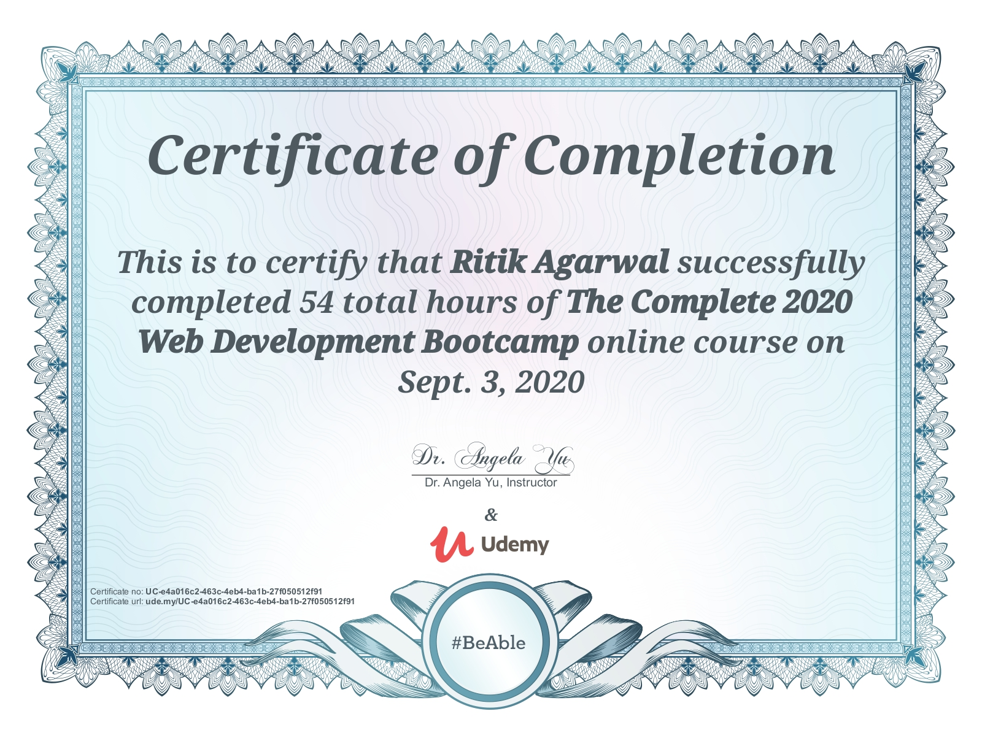

**OVERVIEW**

A newsletter is a printed or electronic report containing news concerning of the activities of a business or an organization that is sent to its members, customers, employees or other subscribers. Newsletters generally contain one main topic of interest to its recipients. A newsletter may be considered grey literature. E-newsletters are delivered electronically via e-mail and can be viewed as spamming if e-mail marketing is sent unsolicited.

**INTRODUCTION ABOUT THE COURSE**

It’s a 50+ hours Web Development course the **most comprehensive**web development course available online. Even if you have **zero** programming experience, this course will take you from **beginner to mastery.** Here's why:

* The course is a taught by the **lead instructor** at the App Brewery, London's **leading in-person programming bootcamp**.
* The course has been updated to be **2020 ready**and you'll be learning the latest tools and technologies used at large companies such as Apple, Google and Netflix.
* This course doesn't cut any corners, there are beautiful **animated explanation videos** and tens of **real-world projects** which you will get to build.
* The curriculum was developed over a period of **four years**, with comprehensive student testing and feedback.

In this course we learnt many Web development languages few of them are mention below -:

* **HTML** 5
* **CSS** 3
* **Bootstrap** 4
* JavascriptES6
* DOM Manipulation
* **jQuery**
* Bash Command Line
* Git, **GitHub** and Version Control
* **Node**.js
* NPM
* **Express**.js
* **APIs**
* Databases
* **React**.js
* Web Design

**INTRODUCTION**

In this project we are making a sign in for NEWSLETTER .What we are doing is we collect the name of the user and his mail id .Using Mailchimp’s API store that data on the server and use that mail id to update its members, customers, employees or other subscribers.

Basically a Newsletters generally contain one main topic of interest to its recipients. A newsletter may be considered grey literature. E-newsletters are delivered electronically via e-mail and can be viewed as spamming if e-mail marketing is sent unsolicited.

Ones they subscribed the user they will receive update regarding any new information of data that the organisation want to send to them. They can unsubscribe the NEWSLETTER by just contacting the organization through mail or any other social media platforms.

**PROJECT OBJECTIVE**

Talk to any marketer these days and you’ll be told the same thing: You need an email list and you need to work hard at building that list.

Part of building a successful list is sending regular email newsletters. The purpose of an email newsletter is to give [those on your list updates](https://www.campaignmonitor.com/blog/email-marketing/2018/08/why-email-newsletters-need-be-part-of-digital-marketing-strategy/) pertaining to your business, products, and services. However, it’s not something that’s generally used for a hard sell. An email newsletter should feel like an update from an interesting, helpful friend, rather than a pushy salesperson. That’s not to say that these newsletters are simply used to keep in touch.

They can be used to motivate your customers to take action, like making a purchase or checking out your latest blog post. Newsletter are often the life force of your marketing campaign. Over the past decade, email marketing has proven to be significantly more successful than social media marketing.

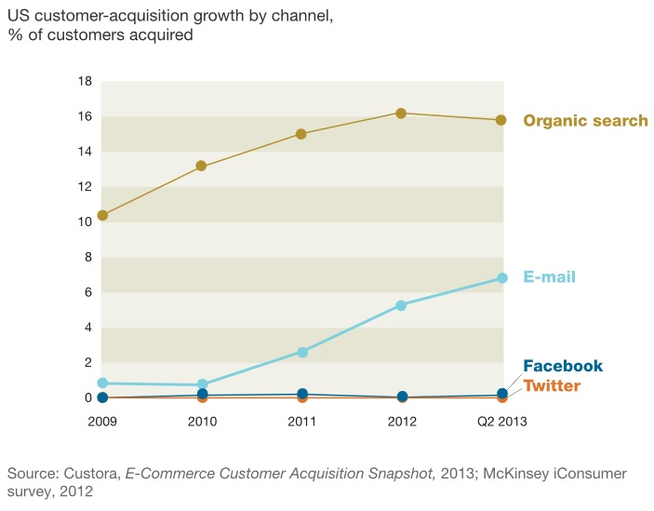

**According to McKinsey researchers, you’re 40 times more likely to get new customer from email marketing than from Facebook or Twitter.**

**FUNCTIONALITY**

Newsletters keep customers and prospects up to date with developments in your company. By selecting the right content, you can keep your audience informed on topics such as new products, special promotional offers and your company’s participation in exhibitions and conferences.

We can also use newsletters to inform customers about your financial results and any important executive, sales or customer service appointments. Keeping customers informed about developments ensures that they are aware of your company's status as an innovative, well-managed supplier.

**SYSTEM SPECIFICATIONS**

**HARDWARE REQUIREMENT -:**

* Processor: Minimum 1 GHz; Recommended 2GHz or more.
* Ethernet connection (LAN) OR a wireless adapter (Wi-Fi)
* Hard Drive: Minimum 32 GB; Recommended 512 GB or more.
* Memory (RAM): Minimum 1 GB; Recommended 4 GB or above.

**SOFTWARE REQUIREMENT -:**

* Browser ( google chrome, firefox, etc)
* Adobe flash player
* Adobe Reader
* Javascript enabled in browser.

**TOOLS AND PLATFORM**

Tools and platform Used are -:

* Code Editor
* Browser
* Basic Laptop
* Internet connection
* Hyper

Software used -:

* Html
* Css
* Bootstrap
* Javascript
* Node
* Express

**LEARNING OUTCOME**

* Understand the principles of creating an effective web page, including an in-depth consideration of information architecture.
* Become familiar with graphic design principles that relate to web design and learn how to implement theories into practice.
* Develop skills in analyzing the usability of a web site.
* Understand how to plan and conduct user research related to web usability.
* Learn how to utilize different languages of web.
* Learn techniques of responsive web design, including media queries.
* Develop basic programming skills using Javascript and jQuery.
* Learn about the use of APIs .

**LIMITATIONS OF NEWSLETTER**

* Partly low opening rate: Not every newsletter is read. Especially if someone has subscribed to many newsletters.
* Time: a newsletter must also be written. Even if you can keep the effort low if you do it skill fully.
* Little success if the content is not interesting for readers and offers no added value.
* If you offer something that your readers urgently need, a newsletter is usually not worth it. Because they want it right now.

**FUTURE SCOPE OF PROJECT**

Email is most common thing which almost every person have whether it’s a student or a business man. Newsletter use Email as source to interact with different user to share information among subscriber.

As the growth of society increases there are more people who are surfing through the internet and approx. more than 40 times there is a possibility of getting new customer from email marketing than from Facebook or Twitter.

Chat bot can be used in future to improve user interaction with the website along with that we can add many section regarding the organization which are sending Newsletters. Database can be used to store more detailed information of the user like birthday date, preferences, locality ,etc. we can also change the layout so that user can have a smooth interaction with the website.

**CODE**

**Html Files**

1. 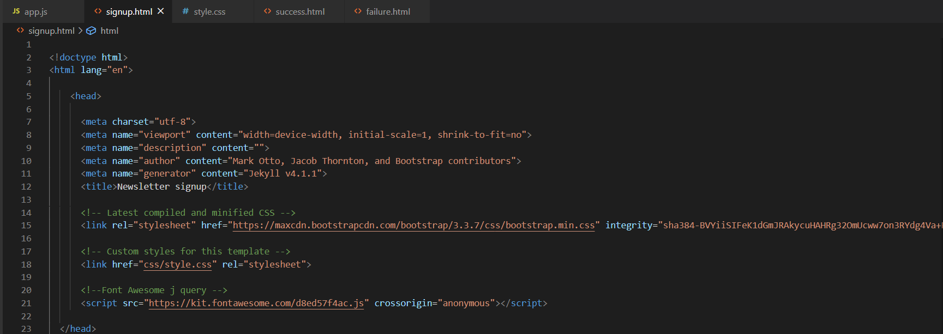Sign up file

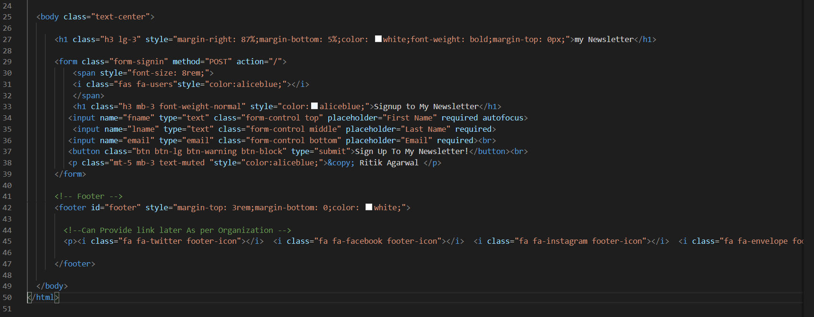

Sign up file is for home page where user will sign up in our Newsletter.

2. Success file

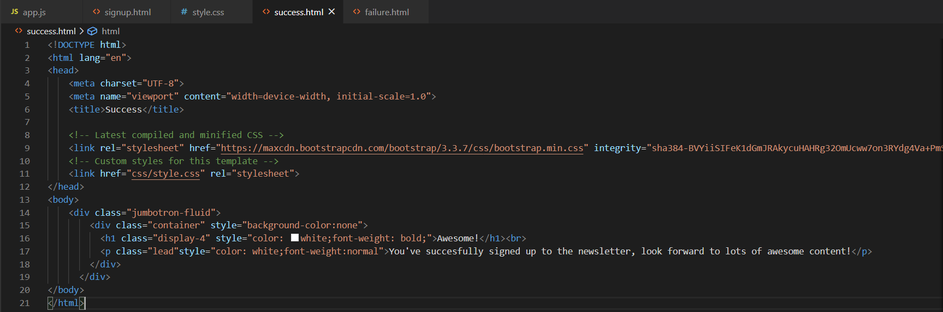

Success file is made so that after success fully sign up in our newsletter user get an update of successfully sign in up.

3. Failure file

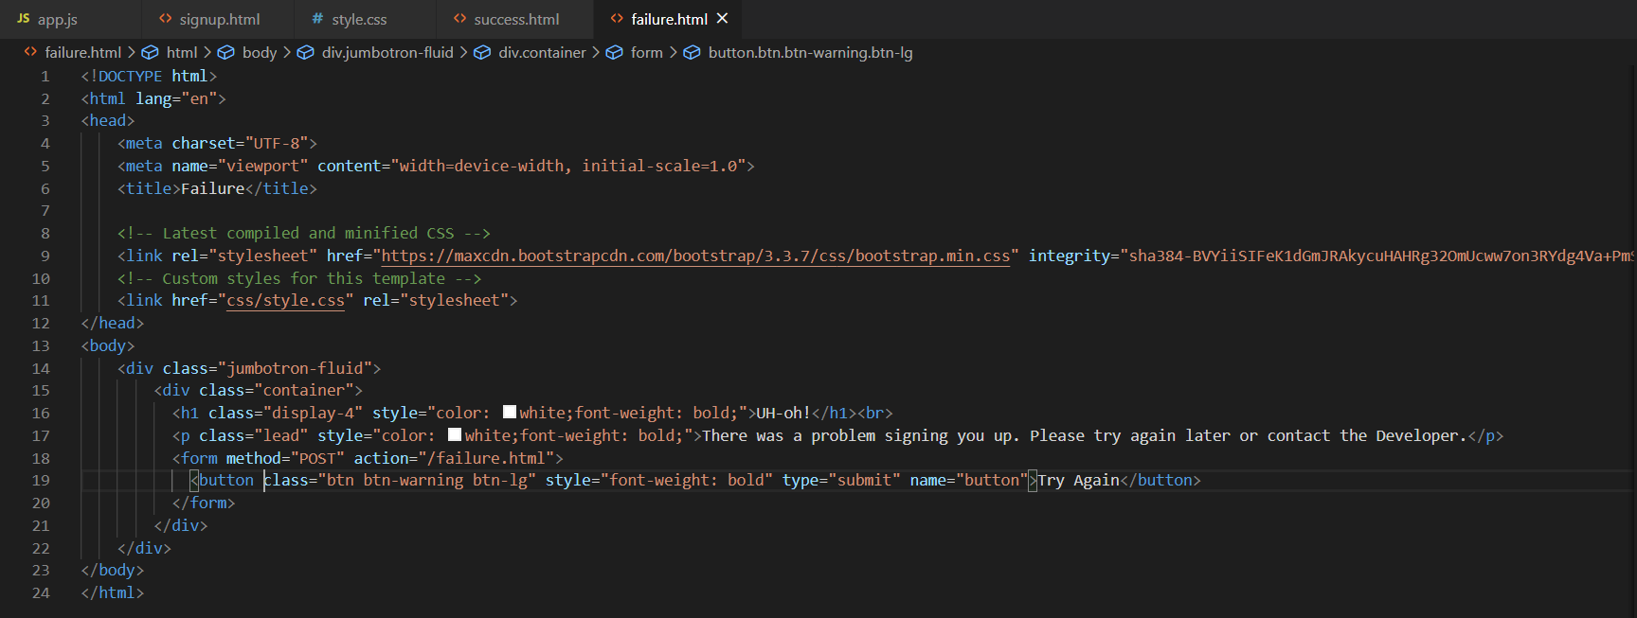

Somehow if there is a failure during sign in process whether due to API or not getting any response this file will show along with a message and a button to allow the user to retry even if it doesn’t work ,then user can contact the developer.

**Java Script file**

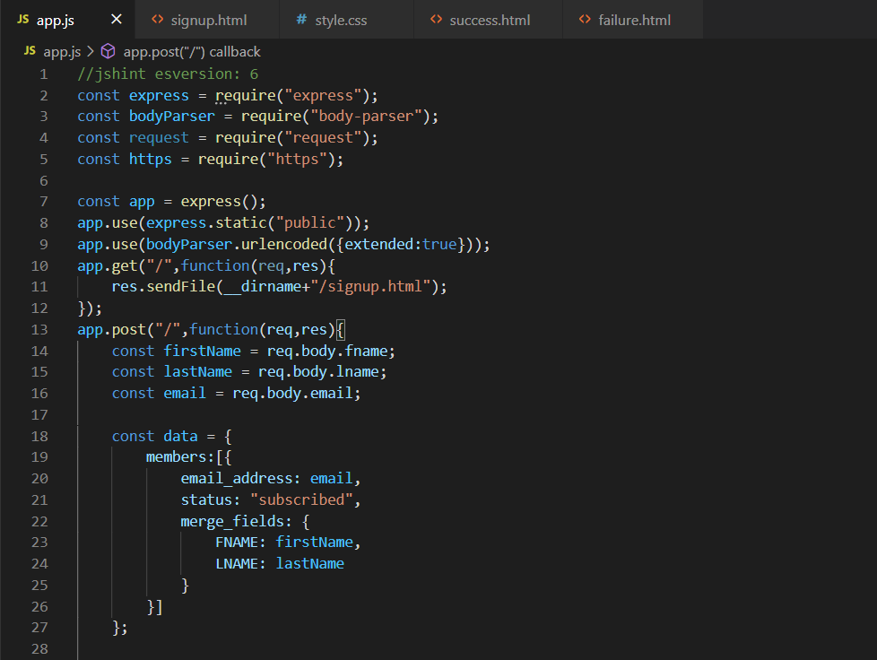

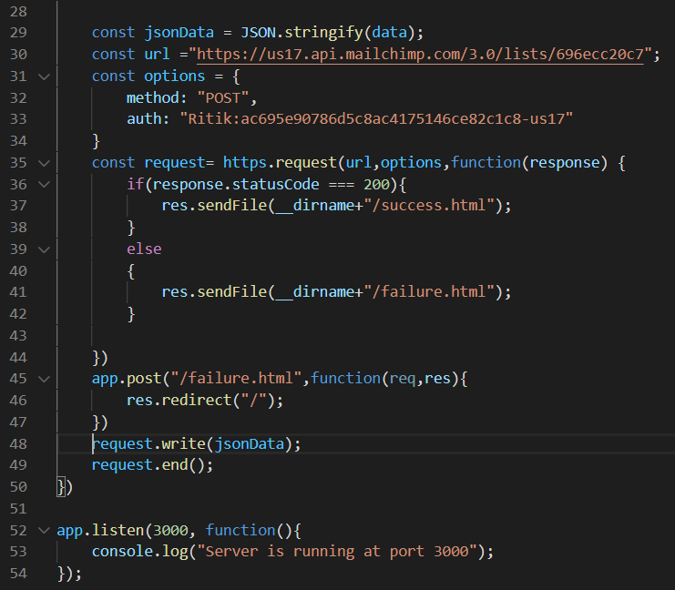Both the above screen shot are a complete js file in which ,with the help of js frame work node and express we are able to send data to the mailchimp server using their API. we also used few node module using npm install .

**CSS file**

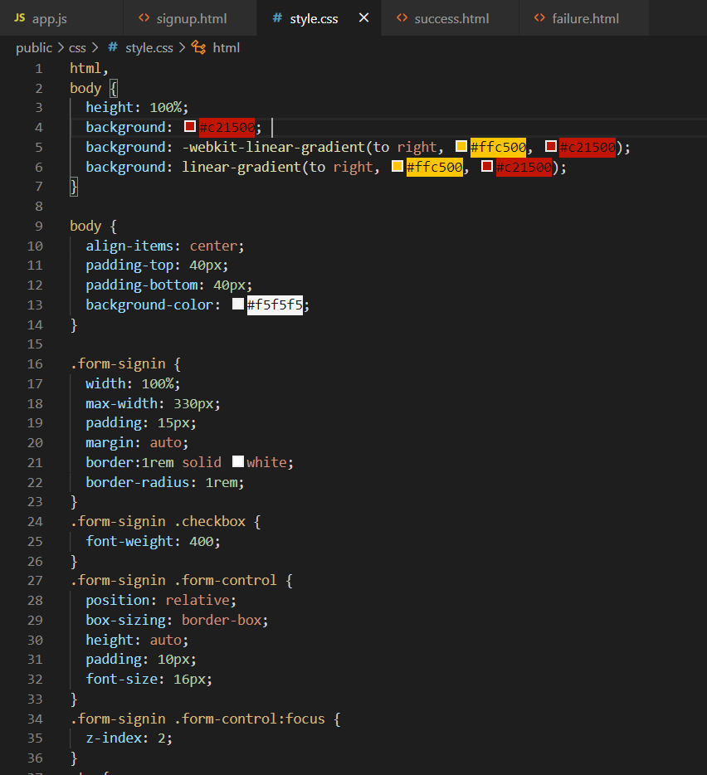

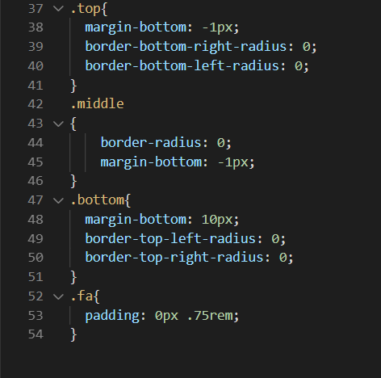

Both the above screen shot is of single css file name style.css . This file contains all the styling of the 3 Html file .

**OUTPUTS**

1. Front End

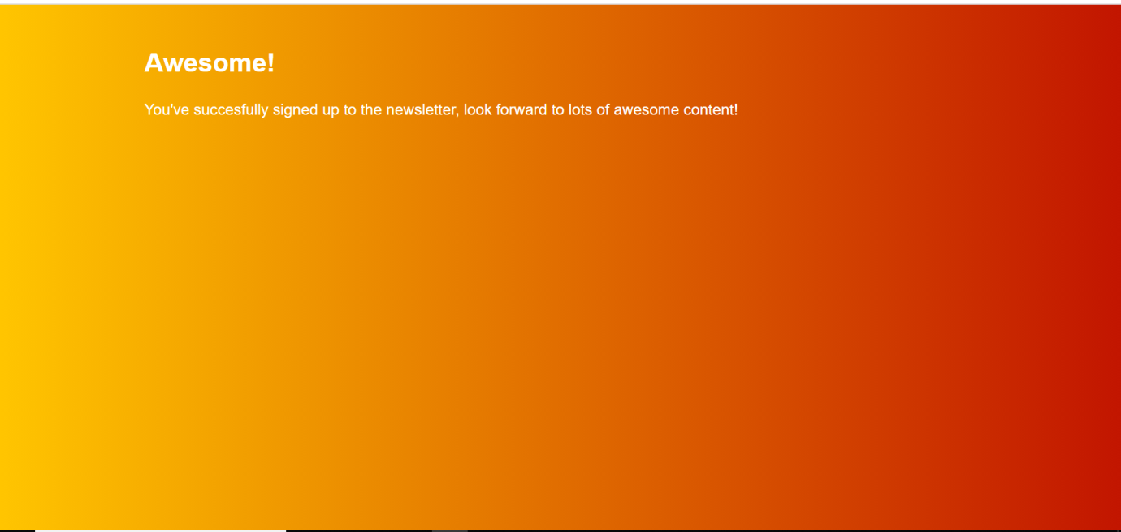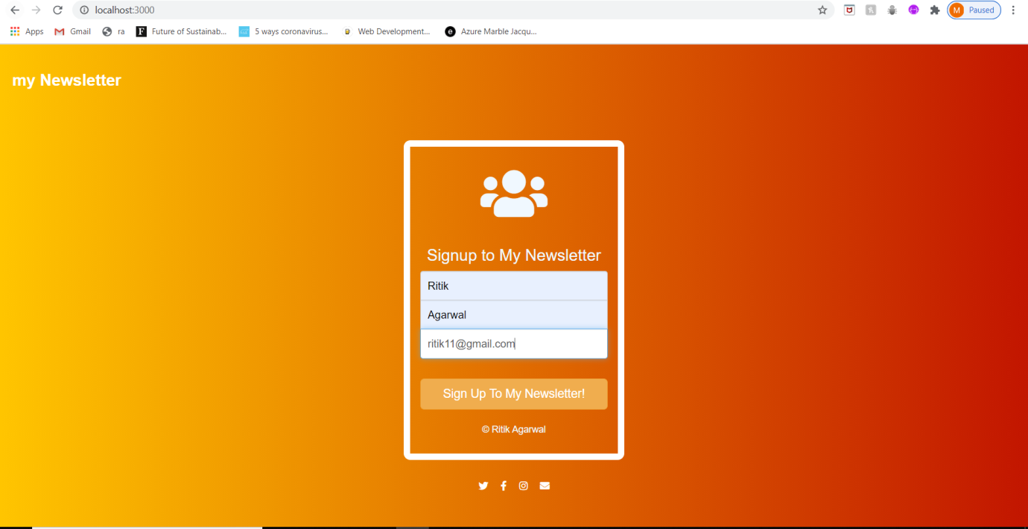

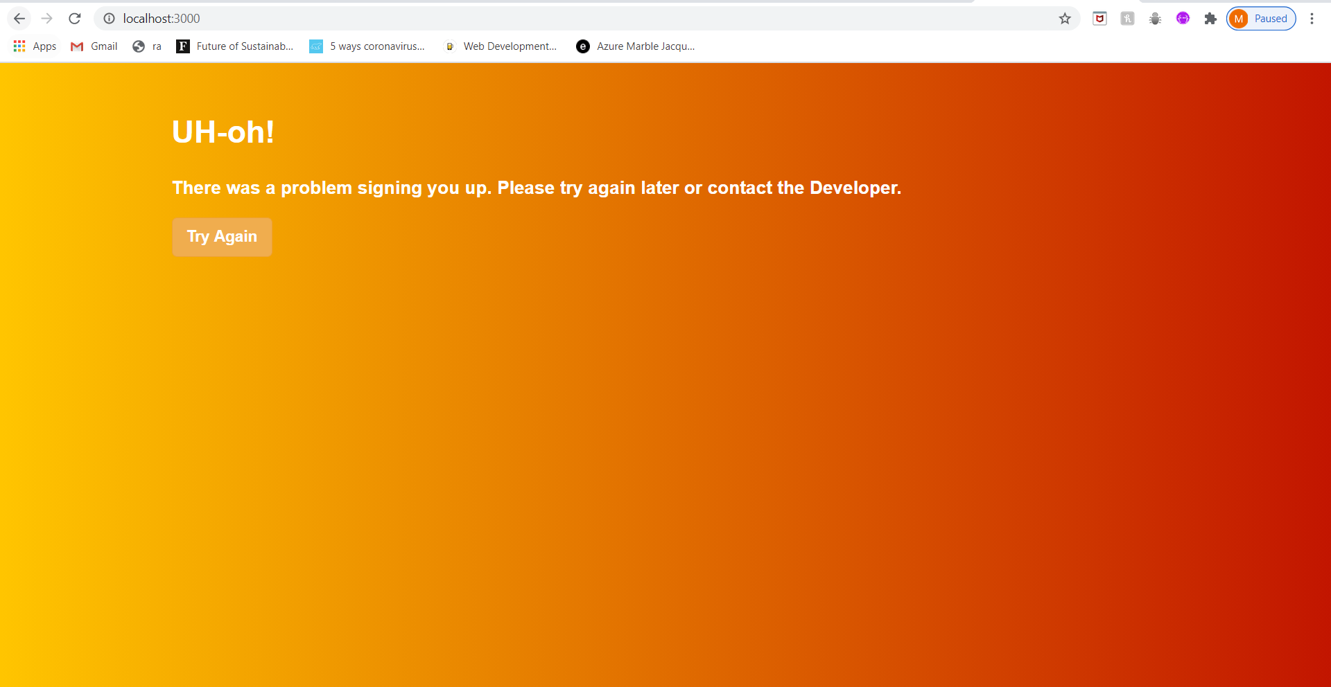

2. CMD

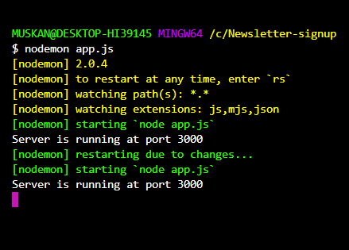

3. Mail Chimp Data Received

